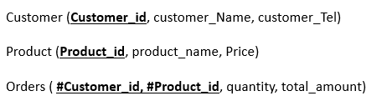

and their corresponding data types tables:

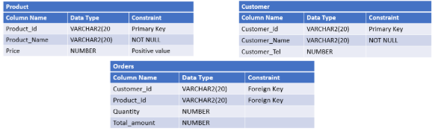

**Instructions**

1. You are asked to create the above given relational model using SQL language and based on the different mentioned constraints.

CREATE TABLE Product (

Product_Id VARCHAR2(20) PRIMARY KEY,

Product_Name VARCHAR2(20) NOT NULL,

Price NUMBER CHECK (Price > 0),

);

CREATE TABLE Customer (

Customer-Id VARCHAR2(20) PRIMARY KEY,

Customer_Name VARCHAR2(20) NOT NULL,

Customer_Tel NUMBER,

);

CREATE TABLE Orders (

Customer_Id VARCHAR2(20),

Product_Id VARCHAR2(20),

Quantity NUMBER,

Total_amount NUMBER,

FOREIGN KEY (Customer_Id) REFERENCES Customer (Customer_Id),

FOREIGN KEY (Product_Id) REFERENCES Product (Product_Id)

)

**Instructions**

2.After creating tables, write SQL commands to:

* + Add a column Category (VARCHAR2(20)) to the PRODUCT table.
  + Add a column OrderDate (DATE)  to the ORDERS table which have SYSDATE as a default value.

ALTER TABLE Product ADD Category VARCHAR2(20);

ALTER TABLE Orders ADD OrderDate DATE DEFAULT SYSDATE ;